Problem 1:

a)

$$P_{prop}= {10}^{\left(-0.1281*Log\left(2.10 m^{3}\right) + 0.2498\right)}=1.62 Mpa$$

b)

$$M_{tank}= \frac{\left(1000000 \frac{pa}{Mpa}\right)*3.23 Mpa*2.10 m^{3}}{9.81 \frac{m}{s^{2}}*5000 m}=138.4 kg$$

c)

These were more complicated equations that required iterations, they are more easily followed in the excel spreadsheet.

Isothermal Volume of Helium = 1.02 Mpa

Isothermal Helium mass = 66.23 kg

Isothermal Helium tank mass = 1241.97 kg

Isothermal Volume of Helium = 1.33 Mpa

Isothermal Helium mass = 86.85 kg

Isothermal Helium tank mass = 1628.55 kg

d)

Figure 1: Propellant tank volume versus pressurant tank volume

Figure 2: Propellant tank mass versus Pressurant tank mass

e) The main difference between the two is the final temperature and pressure at End of Life. This will affect performance the overall mass that will need to be carried with the spacecraft. The more conservative mass estimate would be the isentropic estimate, since it takes into consideration the pressure loss due to temperature decrease. There is a need to bring more Helium along, since the craft will need more pressure to complete its mission.

Problem 2:

a) I chose Engines TR-312-100MN and MR-111C. These were both “rubberized”.

b) The bulk density is in the oxidizer. 1.64 is commonly used to even out the tanks, so it is easier to build two of the same size tanks. This is also a trade off with other variables.

c)

**Table 1: Payload mass breakdown for Cassini spacecraft.**

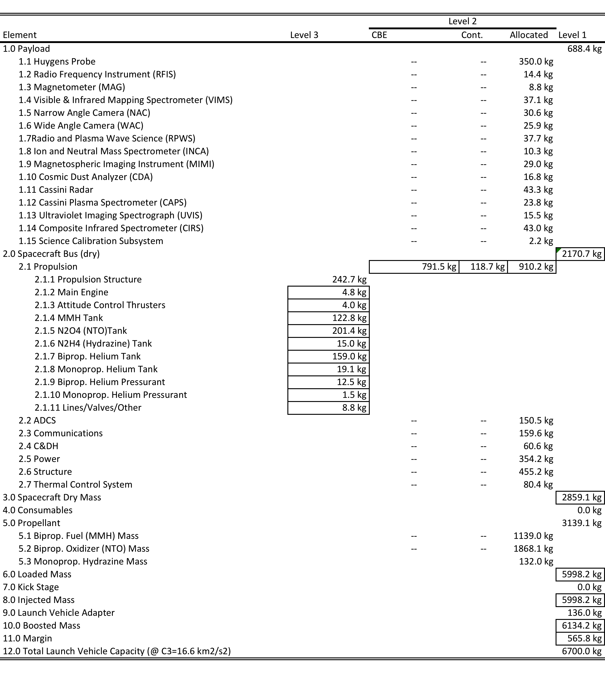

d) The mass margin is around 9.22%. I think this is too low for any part of the planning stage.